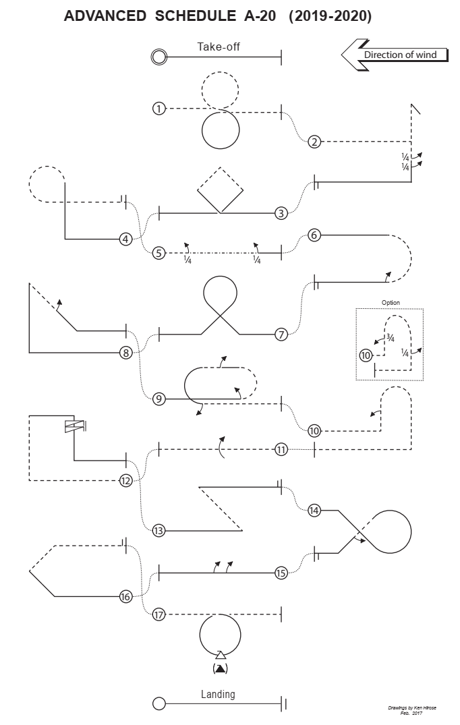
ADVANCED SCHEDULE A-20 (2019-2020)
A-20.01 Vertical 8
From inverted, push through a loop, pull through a loop, exit inverted.
A-20.02 Stall Turn with consecutive two 1⁄4 rolls
From inverted, push through a 1⁄4 loop into a vertical upline, perform a stall turn into a vertical downline, perform consecutively two 1⁄4 rolls, pull through a 1⁄4 loop, exit upright.
A-20.03 Square Loop on Corner
From upright, pull through a 1/8 loop into a 45° upline, pull through a 1⁄4 loop into a 45° upline, pull through a 1⁄4 loop into a 45°downline, pull through a 1⁄4 loop into a 45° downline, pull through a 1/8 loop, exit upright.
A-20.04 Figure 9
From upright, pull through a 1⁄4 loop into a vertical upline, push through a 3⁄4 loop, exit inverted.
A-20.05 Knife-Edge flight with 1⁄4 roll, 1⁄4 roll
From inverted, perform a 1⁄4 roll, perform a knife-edge flight, perform a 1⁄4 roll, exit upright.
A-20.06 Inverted Split S with 1⁄2 roll
From upright, push through a 1⁄2 loop, perform a 1⁄2 roll, exit upright.
A-20.07 Golf Ball
From upright pull through a 1/8 loop into a 45° upline, pull through a 3⁄4 loop into a 45° downline, pull through a 1/8 loop, exit upright.
A-20.08 Shark Fin with 1⁄2 roll
From upright, pull through a 1⁄4 loop into a vertical upline, pull through a 3/8 loop into a 45° downline, perform a 1⁄2 roll, pull through a 1/8 loop, exit upright.
A-20.09 Double Immelman with 1⁄2 roll, 1⁄2 roll, 1⁄2 roll
From upright perform a 1⁄2 roll, push through a 1⁄2 loop, perform a 1⁄2 roll in the centre, pull through a 1⁄2 loop, perform a 1⁄2 roll, exit inverted.
A-20.10 Push-Push-Push Humpty-Bump with 1⁄2 roll (Option: with 3⁄4 roll, 1⁄4 roll)
From inverted, push through a 1⁄4 loop into a vertical upline, perform a 1⁄2 roll, push through a 1⁄2 loop into a vertical downline, push through a 1⁄4 loop, exit inverted.
Option: From inverted, push through a 1⁄4 loop into a vertical upline, perform a 3⁄4 roll, push through a 1⁄2 loop into a vertical downline, perform a 1⁄4 roll, push through a 1⁄4 loop, exit inverted
A-20.11 Roll
From inverted, perform a roll, exit inverted.
A-20.12 Top Hat with spin
From inverted, push through a 1⁄4 loop into a vertical upline, push through a 1⁄4 loop into a horizontal line, perform a spin with 2 turns into a vertical downline, pull through a 1⁄4 loop, exit upright.
A-20.13 Figure Z
From upright, pull through a 3/8 loop into a 45° upline, push through a 3/8 loop, exit upright.
A-20.14 Comet with 1⁄2 roll
From upright, push through a 1/8 loop into a 45° downline, pull through a 3⁄4 loop into a 45° downline, perform a 1⁄2 roll, pull through a 1/8 loop, exit upright.
A-20.15 Roll Combination with consecutive two 1⁄2 rolls
From upright perform consecutively two 1⁄2 rolls, exit upright.
A-20.16 Half Square Loop on Corner
From upright, pull through a 1/8 loop into a 45° upline, pull through a 1⁄4 loop into a 45° upline, pull through a 1/8 loop, exit inverted.
A-20.17 Avalanche
From inverted pull through a loop while performing a snap roll in the low centre, exit inverted

